Lesson 3.4 Modelling With Formulas
Formulas describe an algebraic relationship between two variables. Today we will be reviewing how to insert values and find out information from a formula. We will also look at rearranging and solving formulas to find unknown information.
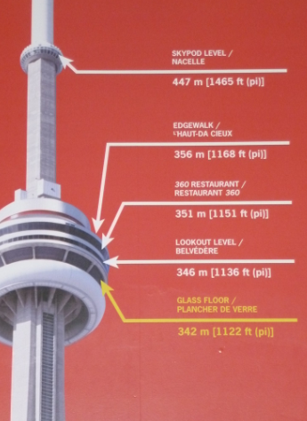
Minds-On:
The higher your altitude, the farther you can see. This relationship can be modelled by the formula
$d=2\sqrt{3.2h}$
Where $h$ is your height, in meteres, above the ground and $d$ is the distance, in kilometres, to the horizon.
Consider the CN tower.
- How far can you see from the restaurant which is 351 m high? Round your answer to the nearest kilometer.

- How far can you see from the observation deck which is 447 m high? Round your answer to the nearest kilometer.

- How high would you have to be in order to see 100 km away? Round your answer to the nearest metre.

- Explain how you found your answer.

- Can you create a formula to find the height you must be, dependent on the distance you would like to see?
Example 1:
- The circumference of a circle can be found by using the formula $C=2πr$. Rearrange this formula to isolate $r$ (that is, determine an equation to represent the radius if the circumference is known).

- The speed of a car can be found by using the formula $s=\frac{d}{t}$, where $s$ is the speed in kilometres/hour, $d$ is the distance in kilometres, and $t$ is the time in hours. Determine an equation to find the distance travelled depending on the speed and time.

- The area of a circle can be found using the formula $A=πr^{2}$. Determine a formula for finding the radius given the area.

Practice:
- Rearrange each formula to isolate the variable indicated.
  - $C=πd$ for $d$ (circumference of a circle)
  - $d=vt$ for $t$ (distance – distance = speed multiplied by time)
  - $A=P+I$ for $I$(investments – total amount = principle plus interest)
  - $F=ma$ for $a$ (Force = mass X acceleration)
  - $V=IR$ for $R$ (voltage = current X resistance)
  - $V=s^{3}$ for $s$ (volume of a cube = side length cubed)
  - $P=I^{2}R$ for $R$ (Power = current squared X resistance)
  - $V=πr^{2}h$ for $h$ (Volume of a cylinder = pi X radius squared X height of cylinder)
  - $P=2l+2w$ for $l$ (Perimeter of a rectangle = 2 lengths + 2 widths)
  - $A=\frac{bh}{2}$ for $h$ (area of a triangle = base X height divided by 2)
  - $c^{2}=a^{2}+b^{2}$ for $a$ (Pythagorean theorem)

- You can use the formula $p=2.2k$ to obtain an approximate value for converting a mass, $k$, in kilograms to mass in pounds, $p.$
  - Use the formula to find the number of pound in 3 kg.
  - Rearrange the formula to express the $k$ in terms of $p$. (ie. To find the kilograms based on pounds).
  - How many kilograms are in 8 pounds? Round your answer to the nearest tenth of a kilogram.

- The surface area, $A$, of a cube is related to the length of a side of the cube, $s$, by the formula $A=6s^{2}.$
  - Rearrange this formula to express the side length in terms of the area.
  - Find the length of the side of cube with a surface area of 800 ${cm}^{2}$. Round your answer to the nearest tenth of a centimetre.

- Bill is a hotel manager. His responsibilities include renting rooms for conferences. The hotel charges $250 per day plus $15 per person for the grand ballroom.
  - Create a formula that relates the cost, $C,$in dollars of renting the ballroom to the number of people, $n.$ Assume the rental is for 1 day.
  - How much should Bill charge to rent the hall for
    - 50 people?
    - 100 people?
  - Rearrange your formula to find the number of people, $n,$in terms of the cost, $C$.
  - How many people could attend a wedding reception if the wedding planners have a budget of
    - $4000?
    - $2000?

